For Mainboard
(design can refer to 3D print adapter RAMPS 1.4)
1. Power supply 24V two-way input, power terminal: plug-in type
two。 Motor emergency stop switch
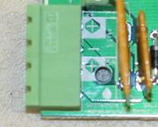
a. Switch entrance VH2PIN connector
b. Motor drive power interface (6), emergency stop switch control motor drive end and 24V power supply on and off. XH2.54-2P
3. Motor driver output (6)
Motor driver signal line interface: XH2.54-4P connector
Drive 1 pin: STEP1_PIN D2 DIR1_PIN D 3 GND
Drive 2 pin: STEP2_PIN D4 DIR2_PIN D5 GND
Drive 3 pin: STEP3_PIN D6 DIR3_PIN D7 GND
Drive 4 pin: STEP4_PIN D8 DIR4_PIN D9 GND
Drive 5 pin: STEP5_PIN D10 DIR5_PIN D11 GND
Drive 6 pin: STEP6_PIN D12 DIR6_PIN D13 GND
Drive 7 pin: STEP7_PIN D14 DIR7_PIN D15 GND
4. Steering gear output (10 channels)
Steering gear power supply independent power supply (6V), shared with Arduino.
D22 D24 D26 D28 D30 D34 D36 D38 D40
VCC(6V)
GND GND
5. Red Light output (24V) Digital Transmission I / O Port output Control Relay Control
D65 (A11) controls one relay, and the relay controls 24V on and off, thus controlling the lights on and off
6. Green light output (24V) Digital output I / O output control relay control
D66 (A12) controls one relay, and the relay controls 24V on and off, thus controlling the lights on and off
7. Red button input (reset function) Reset GND
8. Green button input (program continues) A15
9.PS2 remote control handle receiver input.
D42 D44 D46 D48 3.3V GND
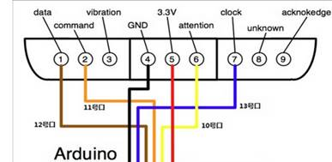
10. Bluetooth interface
Cooperate with HC-06 Bluetooth module
Empty 5V GND D18 (TX1) D19 (RX1) empty
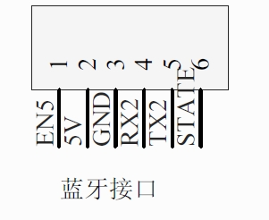
11.LCD screen
D16 D17 D23 D25 D27 D29 D31 D33 D35 D37 D39 D41 D43 D45 D47 D32 GND 5V
12.SPI interface (SD card supported)
D49 D50 D51 D52 D53
13.I2C 21 20 GND 5V
14. Two heat dissipation fan outputs (24V)
转接板设计
（设计参考3D打印转接板RAMPS 1.4）
1.电源24V两路输入，电源端子：插拔式
2.电机急停开关
a.开关接入口 VH2PIN 连接器
b.电机驱动电源接口（6个），急停开关控制电机驱动器端与24V电源的通断。XH2.54-2P
3.电机驱动器输出（6个）
电机驱动器信号线接口：XH2.54-4P 连接器
驱动器1引脚：STEP1_PIN D2 DIR1_PIN D3 GND
驱动器2引脚：STEP2_PIN D4 DIR2_PIN D5 GND
驱动器3引脚：STEP3_PIN D6 DIR3_PIN D7 GND
驱动器4引脚：STEP4_PIN D8 DIR4_PIN D9 GND
驱动器5引脚：STEP5_PIN D10 DIR5_PIN D11 GND
驱动器6引脚：STEP6_PIN D12 DIR6_PIN D13 GND
驱动器7引脚：STEP7_PIN D14 DIR7_PIN D15 GND
4.舵机输出（10路）
舵机电源独立供电（6V），与Arduino共地。
D22 D24 D26 D28 D30 D34 D36 D38 D40
VCC VCC VCC VCC VCC VCC VCC VCC VCC VCC (6V)
GND GND GND GND GND GND GND GND GND GND

5.红灯输出（24V） 数字输I/O口输出控制继电器控制
D65(A11) 控制一路继电器，继电器控制24V通断，从而控制灯的亮灭
6.绿灯输出（24V） 数字输I/O口输出控制继电器控制
D66(A12) 控制一路继电器，继电器控制24V通断，从而控制灯的亮灭
7.红色按钮输入(复位功能) Reset GND
8.绿色按钮输入（程序继续运行） A15
9.PS2遥控手柄接收器输入。
D42 D44 D46 D48 3.3V GND

10．蓝牙接口
配合HC-06蓝牙模块
空 5V GND D18（TX1） D19（RX1） 空
11.LCD屏
D16 D17 D23 D25 D27 D29 D31 D33 D35 D37 D39 D41 D43 D45 D47 D32 GND 5V
12.SPI接口（支持SD卡）
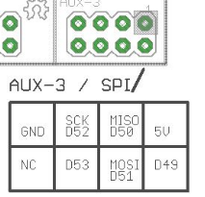
D49 D50 D51 D52 D53
13.I2C
21 20 GND 5V
14.两个散热风扇输出（24V）

